Software Architecture Document

Individual Project



Done by: Stanislav Petkov (4222024)

Class: S3-CB04

Version: 1.0

|  |  |
| --- | --- |
| Version | Changes |
| 0.1 | - Initial version |
| 1.0 | - Official Release |

**REVISION HISTORY**

Table of Contents

Introduction 4

System Context (C1) 5

Containers and tech choices (C2) 6

Components (C3) 7

Class diagrams and sequence diagrams 8

Database Design 9

API documentation 10

# Introduction

The purpose of this document is to showcase the architecture of the software system “E-tickets Bayern”, to guarantee a SOLID architectural design and provide explanation on framework choices and how the system is going to operate.

This web application is going to provide an online ticketing service for the football club “FC Bayern Munich”, where the fans of the club will be able to book tickets, the administrators of the service will be able to keep the overview of events of the team up-to-date and the managers will have the ability to view financial statistics regarding the sales generated by this software system.

# System Context (C1)

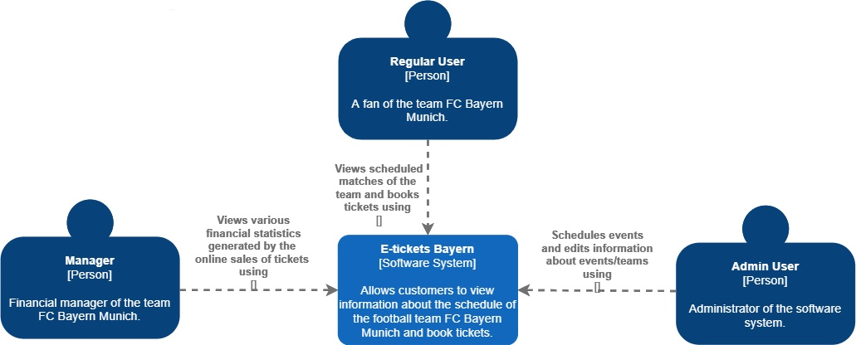

# Containers and tech choices (C2)

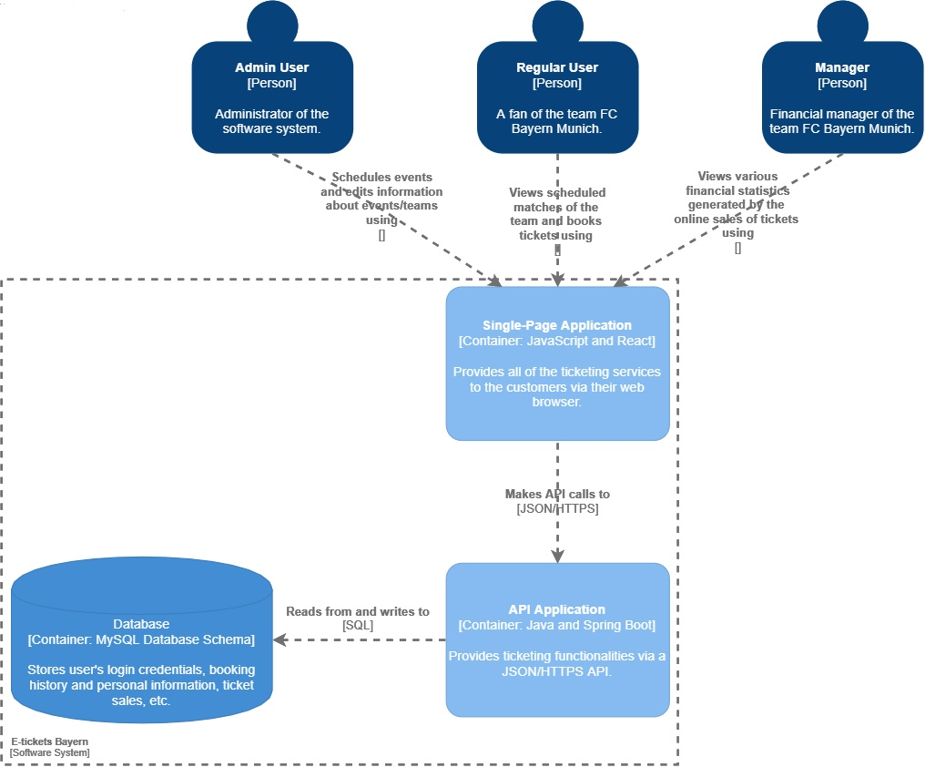

# Components (C3)

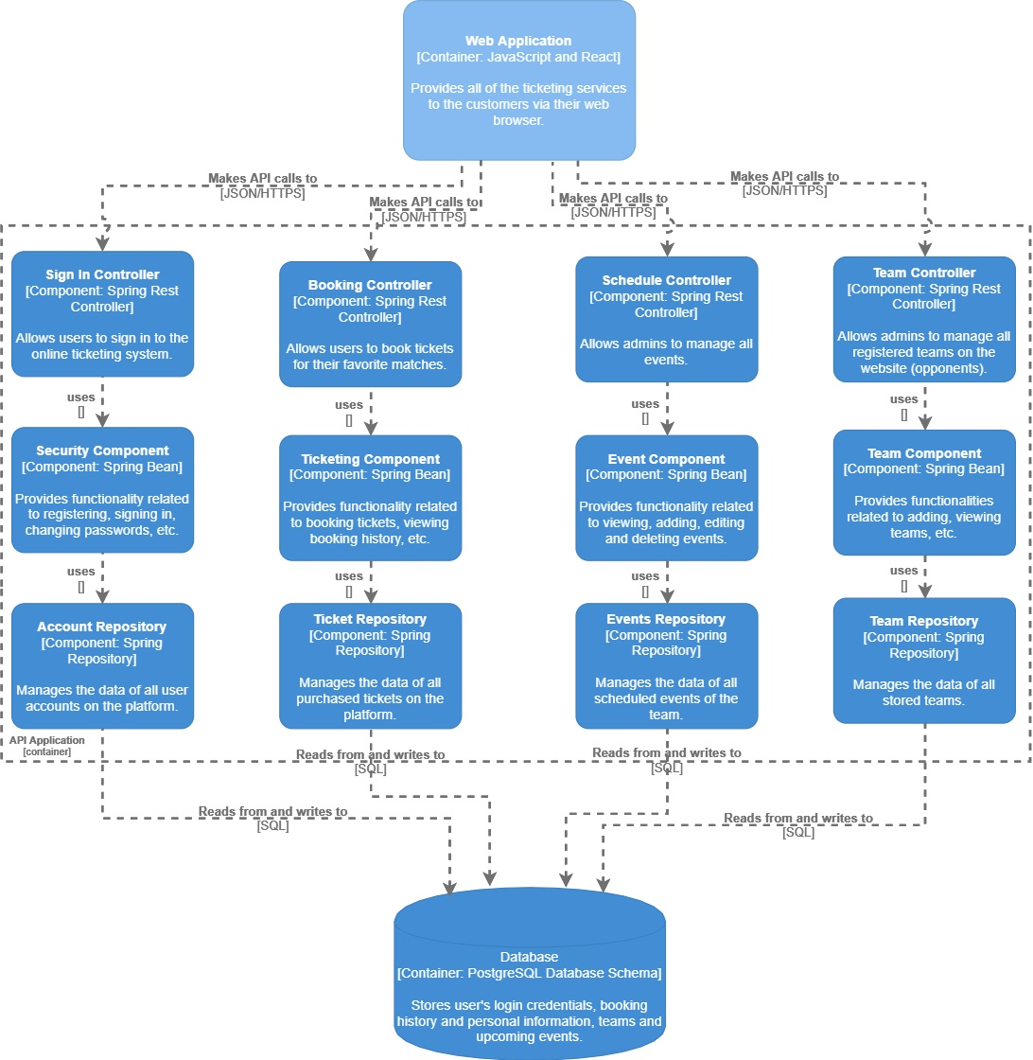

Data Access Layer

Logic Layer

Presentation Layer

Data Persistence: Each of the logic components is going to be stored in a database, so all the valuable data is going to be persistent throughout the application.

# Class diagrams and sequence diagrams

# Database Design

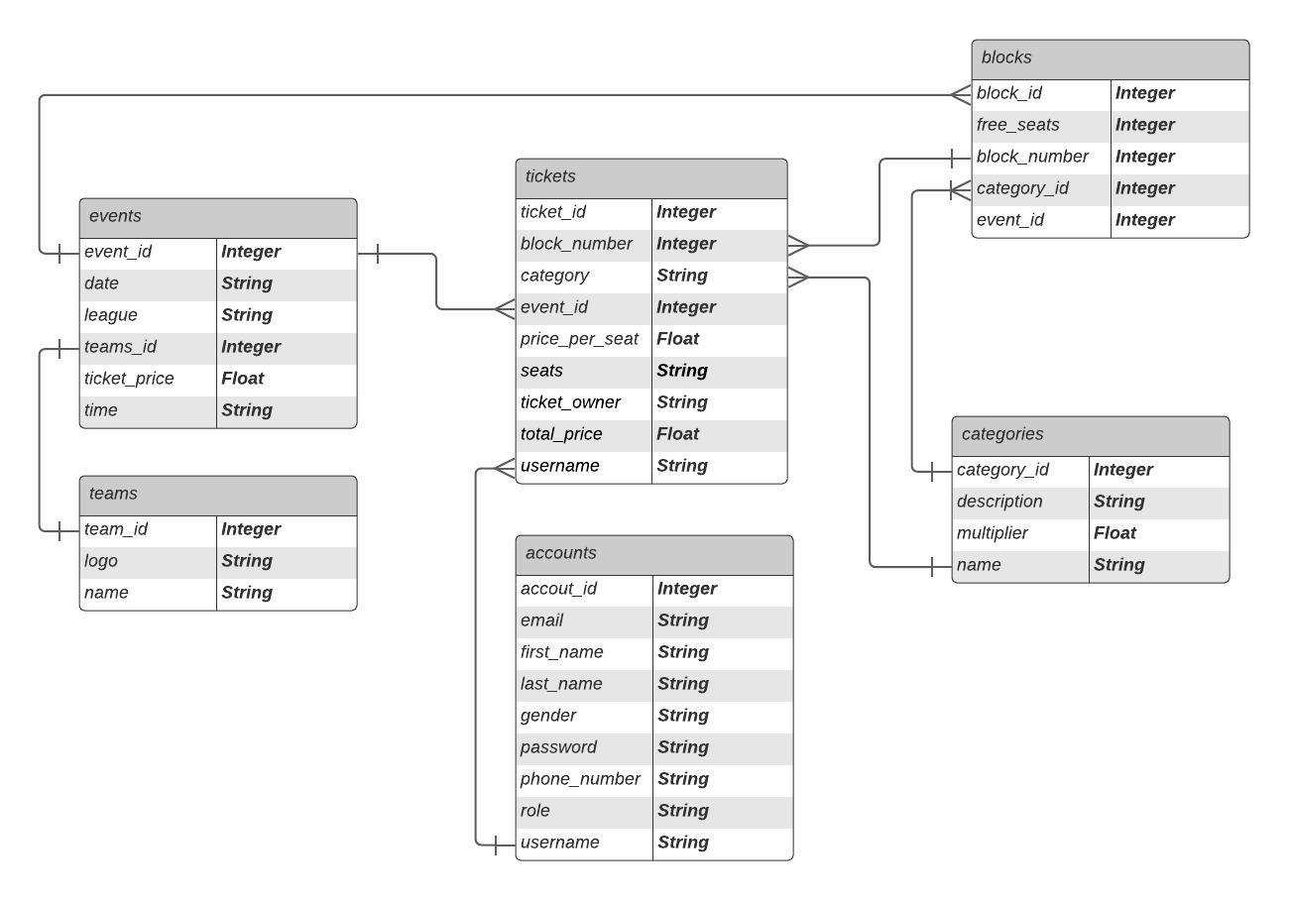

# CI/CD Pipeline

# API documentation

|  |  |  |  |
| --- | --- | --- | --- |
| URL | resource | operation | result |
| /events | Events | GET | read a list with all current events |
| /events | Events | POST | create a new event |
| /events/1 | Events | GET | read an event with id 1 |
| /events/1?categoryId=1 | Events | GET | read a category with id 1 for event with id 1 |
| /events?id=1 | Events | DELETE | delete an event with id 1 |
| /events | Events | PUT | update an event |
| /teams | Teams | GET | read a list with all teams |
| /teams/FC Barcelona | Teams | GET | read a team with a name “FC Barcelona” |
| /teams | Teams | POST | create a new team |
| /tickets | Tickets | GET | read a list with all the bookings of the current user |
| /tickets | Tickets | POST | create a new booking for the current user |
| /categories | Categories | GET | read a list with all the categories |
| /categories/1 | Categories | GET | read a category with id 1 |
| /blocks?eventId=3&categoryId=1&quantity=2 | Blocks | GET | read a list of blocks with 2 or more available seats for category with id 1 of event with id 3 |
| /login | Accounts | POST | provides access token based on correct user credentials |
| /users | Accounts | POST | create a new user account |
| /users | Accounts | GET | read the account information of the current user |
| /users | Accounts | PUT | update the account information of the current user |